**Global Wealth Divide: A Comprehensive Study Of Income Inequality Across The World - (Short-Term)**

Income inequality refers to the unequal distribution of income among individuals or groups in a society. It is often measured using the Gini coefficient, which ranges from 0 (perfect equality, where everyone earns the same income) to 1 (perfect inequality, where one person earns all the income).  
Income inequality can be caused by various factors, including differences in education, skills, experience, occupation, and industry. Other factors that contribute to income inequality include discrimination, globalization, technological change, and government policies.  
High levels of income inequality can have negative impacts on individuals and society as a whole, including lower social mobility, higher poverty rates, increased crime, reduced economic growth, and weakened social cohesion. Therefore, addressing income inequality is an important policy goal for many governments and organizations around the world.

**Business Requirements**

The business requirements for this project would likely include   
**Data collection:**The first requirement is to collect data from the WIID(world income inequality database) compiled by UNU-WIDER

**Data cleaning and preparation**: The collected data must be cleaned and processed to ensure it is suitable for analysis. This may involve removing irrelevant information, correcting inconsistencies and missing values, and transforming the data into a format that is compatible with the analysis tools.

**Data analysis**: The data must be analyzed to uncover meaningful insights into financial independence. This could involve using techniques such as descriptive statistics, regression analysis, and data visualization to gain a deeper understanding of the data.

**Report creation**: The insights and findings from the data analysis must be presented in a comprehensive report that includes visualizations and data tables. The report must be well organized and easy to understand, with clear and concise explanations of the results

**Literature Survey**

A literature survey for a project titled "Global Wealth Divide: A Comprehensive Study of Income Inequality Across the World” would involve a review of existing research and studies related to economic inequality. The objective of the literature survey would be to understand the current state of knowledge in this area and identify any gaps in the existing research that the project can address.  
Overall, the literature survey would provide a comprehensive overview of the current state of knowledge in the field of financial independence and personal finance, and would provide a foundation for the analysis and report creation aspects of the project.

**Social Or Business Impact**

**Social Impact**: The findings from this project could help people in better planning their finances, and other assets  
  
**Business Model/Impact**: A high level of financial independence for people indicates, healthy economic conditions for the country

**Data Collection & Extraction From Database**

Data collection is the process of gathering and measuring information on variables of interest, in an established systematic fashion that enables one to answer stated research questions, test hypotheses, and evaluate outcomes and generate insights from the data.

**Data Preparation**

Data preparation is the process of cleaning, transforming, and organizing data in order to make it suitable for analysis. It is an important step in the data analysis process, as the quality of the data used can have a significant impact on the accuracy and reliability of the results.

Preparing the data for visualization involves cleaning the data to remove irrelevant or missing data, transforming the data into a format that can be easily visualized, exploring the data to identify patterns and trends, filtering the data to focus on specific subsets of data, preparing the data for visualization software, and ensuring the data is accurate and complete. This process helps to make the data easily understandable and ready for creating visualizations to gain insights into the performance and efficiency.

**Data Visualization**

Data visualization is the process of creating graphical representations of data in order to help people understand and explore the information. The goal of data visualization is to make complex data sets more accessible, intuitive, and easier to interpret. By using visual elements such as charts, graphs, and maps, data visualizations can help people quickly identify patterns, trends, and outliers in the data.

**No Of Unique Visualizations**

The number of unique visualizations that can be created with a given dataset. some common types of visualizations that can be used to analyze the wealth inequality data , include bar charts, line charts, tree maps, scatter plots, pie charts, Maps etc. These visualizations can be used to compare performance, track changes over time, show distribution, and relationships between variables

**Dashboard**

A dashboard is a graphical user interface (GUI) that displays information and data in an organized, easy-to-read format. Dashboards are often used to provide real-time monitoring and analysis of data, and are typically designed for a specific purpose or use case. Dashboards can be used in a variety of settings, such as business, finance, manufacturing, healthcare, and many other industries. They can be used to track key performance indicators (KPIs), monitor performance metrics, and display data in the form of charts, graphs, and tables.

**Responsive And Design Of Dashboard**

The responsiveness and design of a dashboard for analysing the factors important for analysis of wealth inequality is crucial to ensure that the information is easily understandable and actionable. Key considerations for designing a responsive and effective dashboard include user-centred design, clear and concise information, interactivity, data-driven approach, accessibility, customization, and security. The goal is to create a dashboard that is user-friendly, interactive, and data-driven, providing actionable insights   
Once you have created views on different sheets in IBM Cognos, you can pin them and pull them into a dashboard.

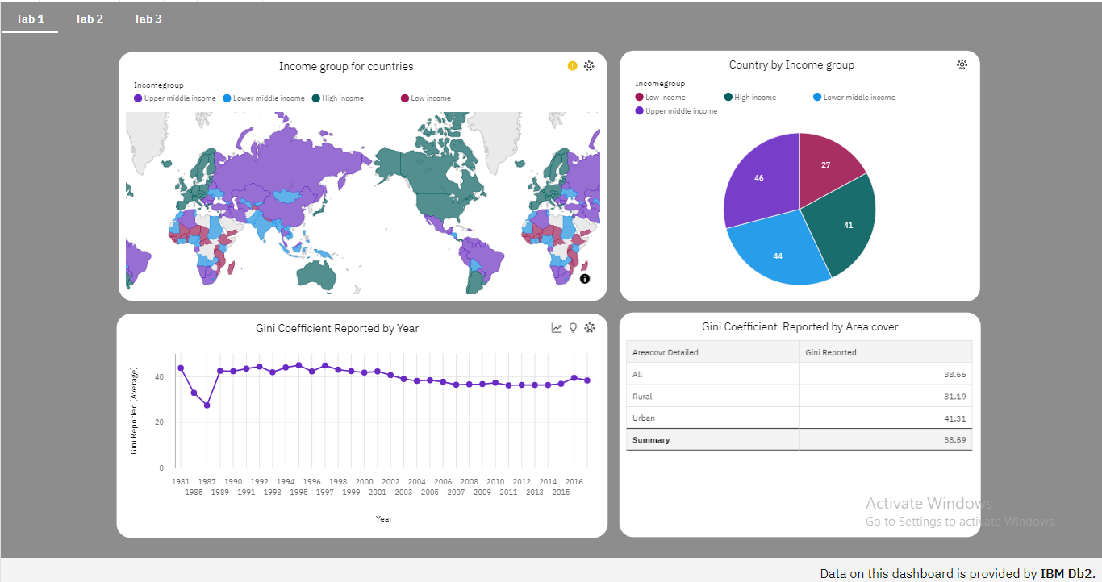

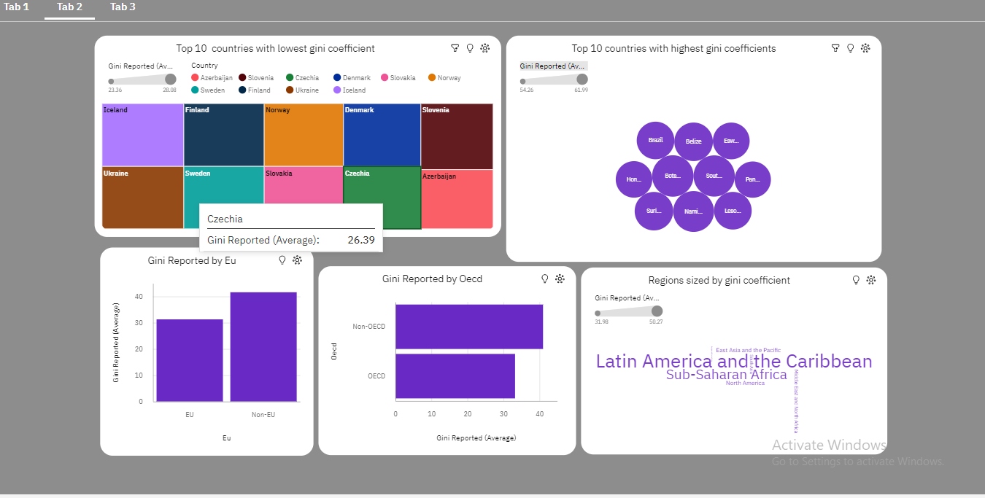

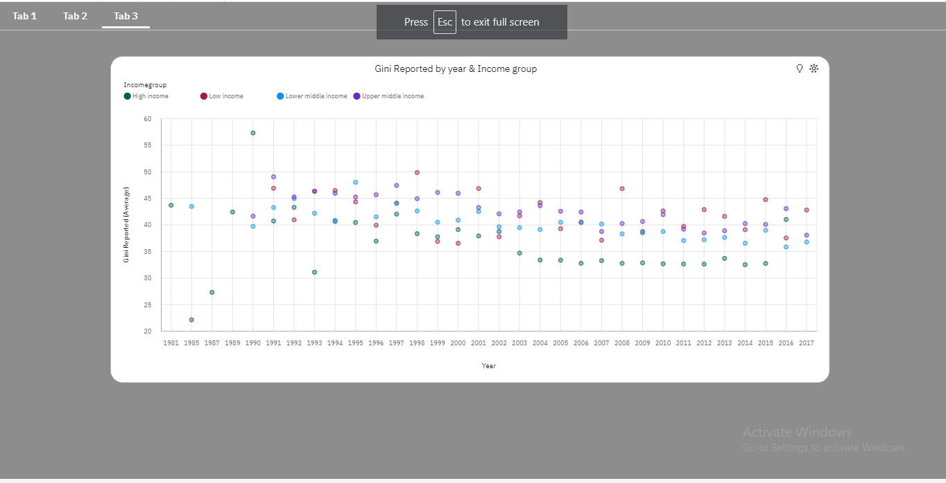

**Story**

A data story is a way of presenting data and analysis in a narrative format, with the goal of making the information more engaging and easier to understand. A data story typically includes a clear introduction that sets the stage and explains the context for the data, a body that presents the data and analysis in a logical and systematic way, and a conclusion that summarizes the key findings and highlights their implications. Data stories can be told using a variety of mediums, such as reports, presentations, interactive visualizations, and videos

**No Of Scenes Of Story**

The number of scenes in a storyboard for a data visualization analysis of the factors causing the income inequality, will depend on the complexity of the analysis and the specific insights that are trying to be conveyed. A storyboard is a visual representation of the data analysis process and it breaks down the analysis into a series of steps or scenes.

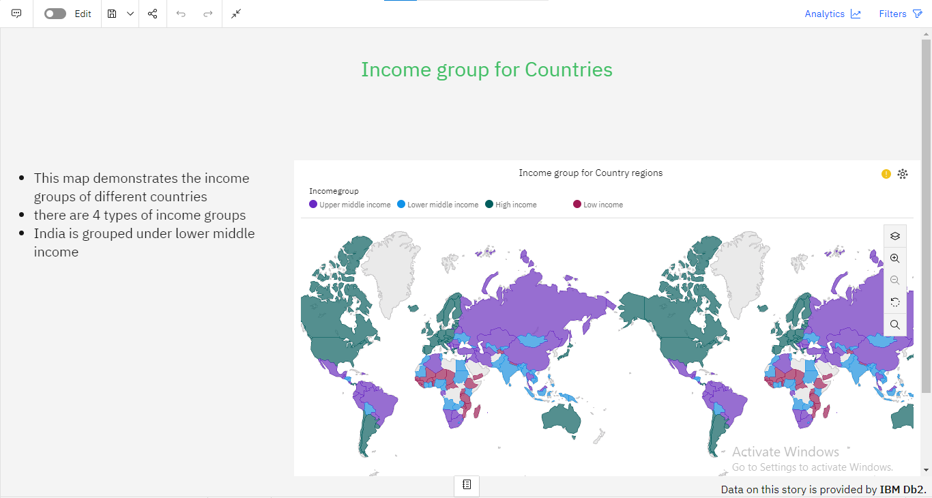

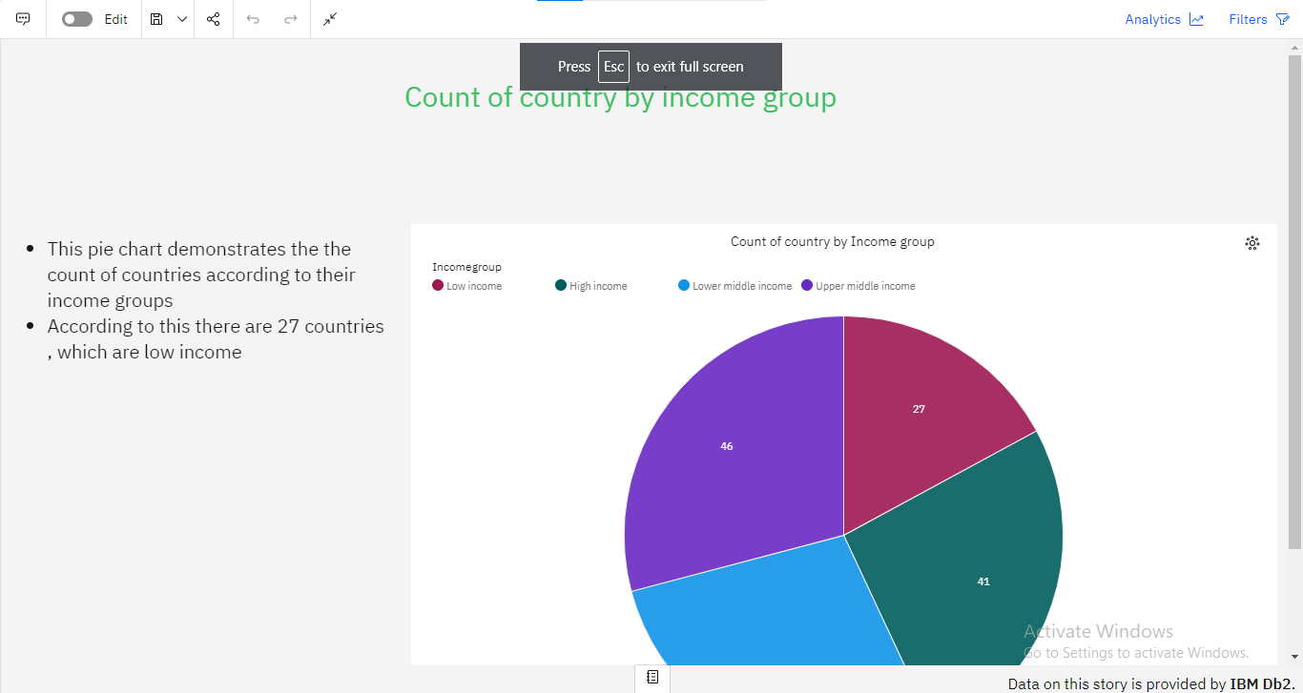

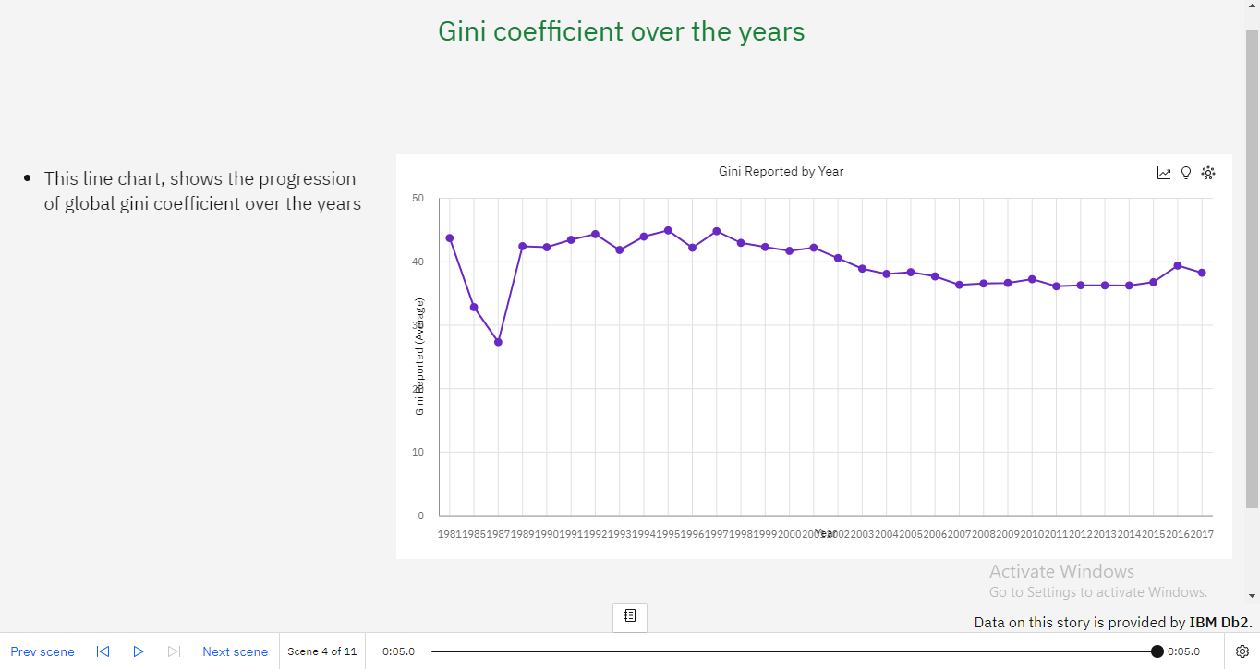

**Report**

A report is a document that presents information in a specific format and layout, usually based on data from a database or other data source. A report in IBM Cognos can contain various elements, such as tables, charts, graphs, and images, as well as text and data elements, and it is designed to be used by business users to help them better understand their data and make informed decisions. There are several different types of reports available in IBM Cognos, including list reports, crosstab reports, chart reports, and report studio reports, among others. The type of report that you choose will depend on the specific needs and requirements of your organization, as well as the data that you need to present.

**Creating A Report**

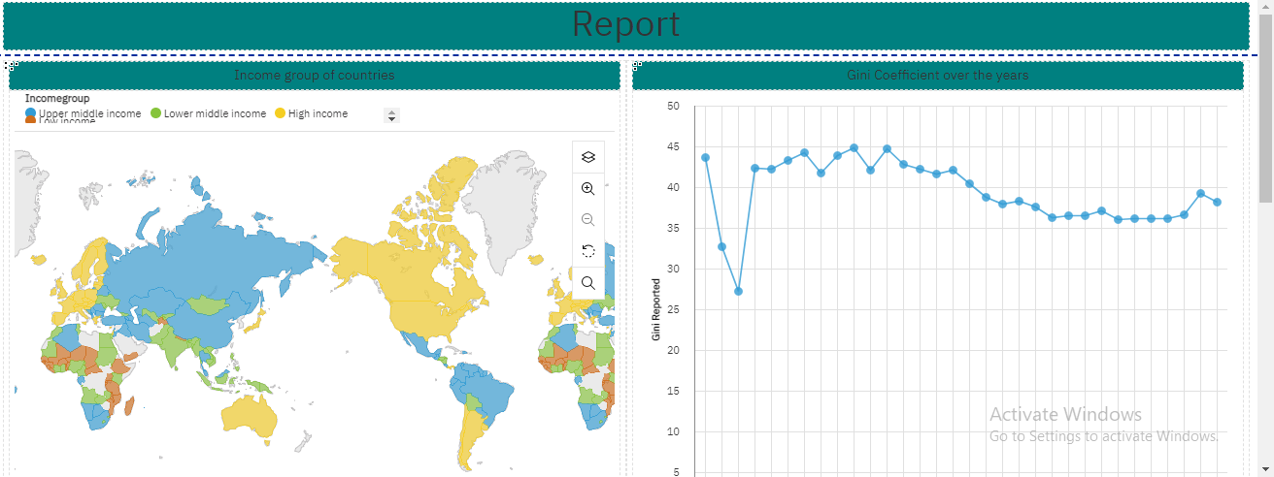

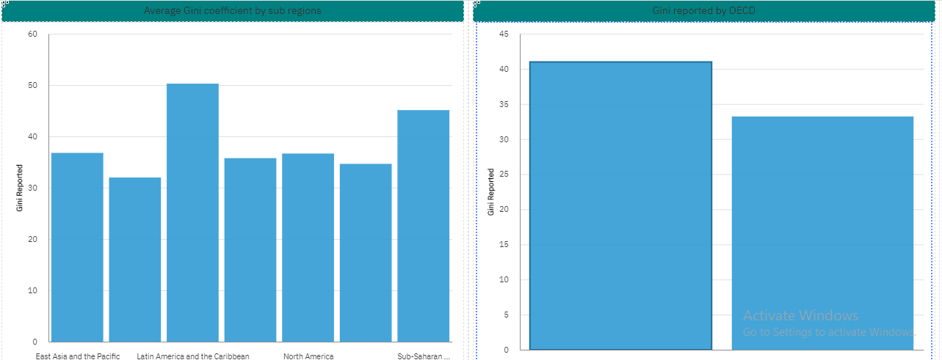

**Performance Testing**

Performance testing is a type of software testing that evaluates how a system or application performs under different workloads and conditions. The goal of performance testing is to identify any performance issues or bottlenecks that may exist and to determine whether the system can handle its expected workload

**Utilization Of Data Filters**

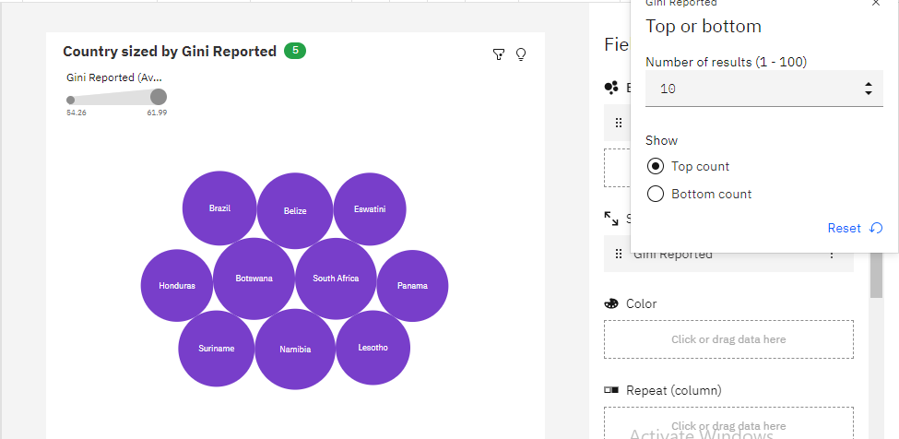

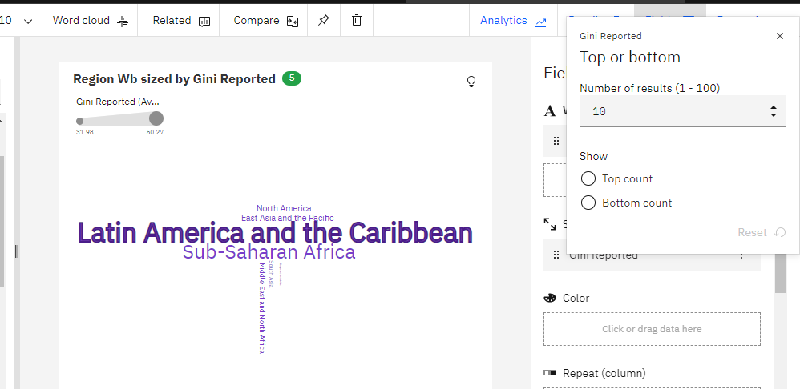

**No Of Calculation Fields**

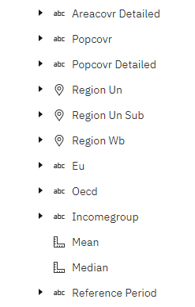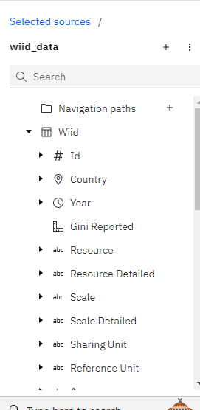

**No Of Visualizations/ Graphs**

* Average gini score over the years
* Average gini score by oecd & non-oecd
* Average gini score by sub regions of the world
* Average gini score by EU & Non-EU   countries
* Top 10 countries by lowest gini coefficient(score)
* Top 10 countries by highest gini coefficient(score)
* Count of countries by income group
* Average gini score by area
* Average gini score of different income groups over the years
* Income group for countries

**Web Integration**

Publishing helps us to track and monitor key performance metrics, to communicate results and progress. help a publisher stay informed, make better decisions, and communicate their performance to others.

**Integrating dashboard/reports/stories to web**

Step 1: Go to Dashboard/story/report, click on share button on the top ribbon

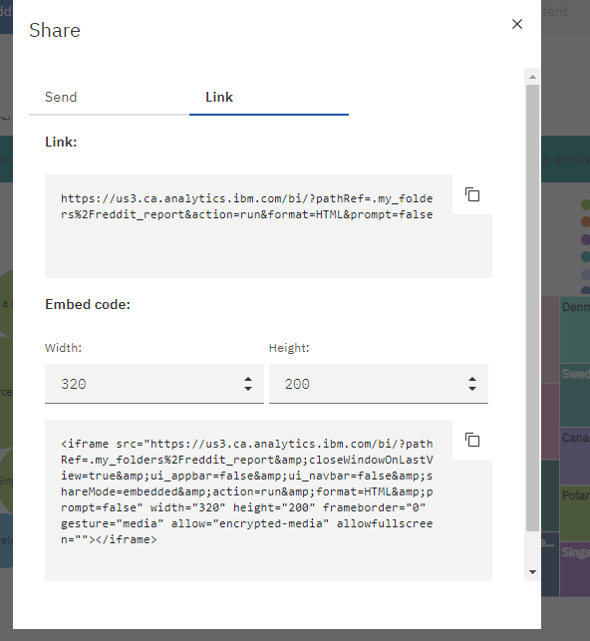

**Dashboard And Story Embed With UI With Flask**

